1)Create a directory "exercise" inside your home directory and create nested(dir1/dir2/dir3) directory structure inside "exercise" with a single command.

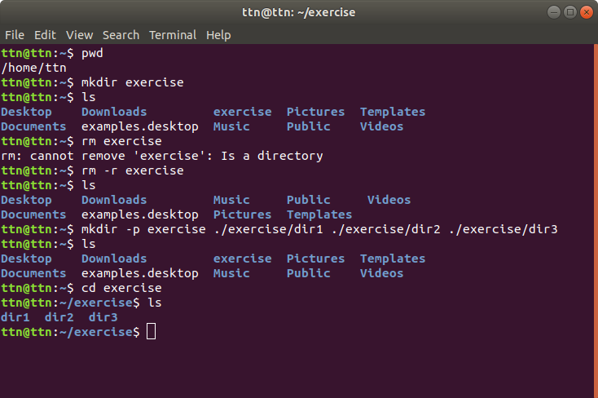

2)Create two empty files inside dir2 directory: emptyFile1,emptyFile2 in single command

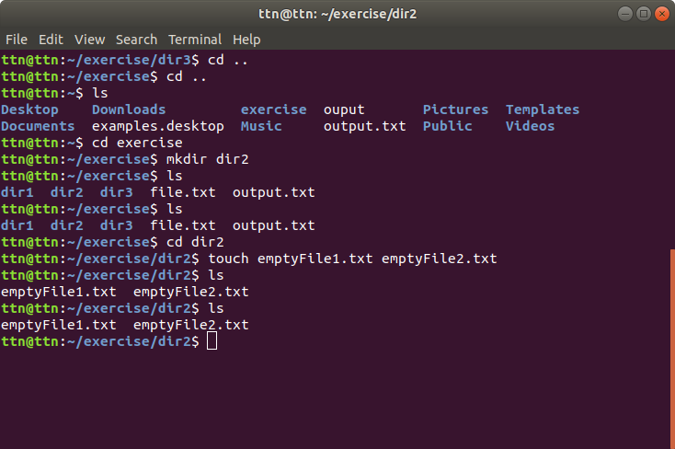

3)Create one file file1.txt containing text "hello world" and save it.

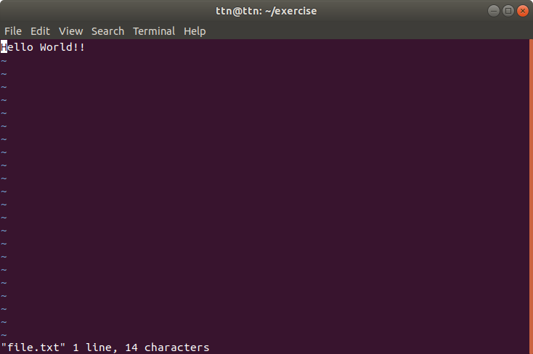

4)Find a "passwd" file using find command inside /etc. copy this file as passwd_copy and then rename this file as passwd_backup.

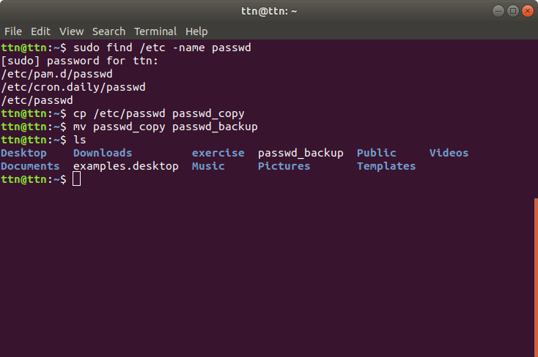

5)Try reading the passwd_backup file in multiple tools: less,more,cat,strings etc and find the difference in their usage.

Less command:Less command is linux utility which can be used to read contents of text file one page(one screen) per time

Command: less passwd_backup

More command:more command is used to view the text files in the command prompt, displaying one screen at a time in case the file is large (For example log files)

Command:more passwd_backup

cat:Cat(concatenate) command is very frequently used in Linux. It reads data from the file and gives their content as output. It helps us to create, view, concatenate files.

Command:cat passwd_backup

Strings: strings are mainly useful for determining the contents of non-text files.

Command:strings passwd_backup

Diff: stands for difference This command is used to display the differences in the files by comparing the files line by line.

6)Find out the number of line in password_backup containing "/bin/false".

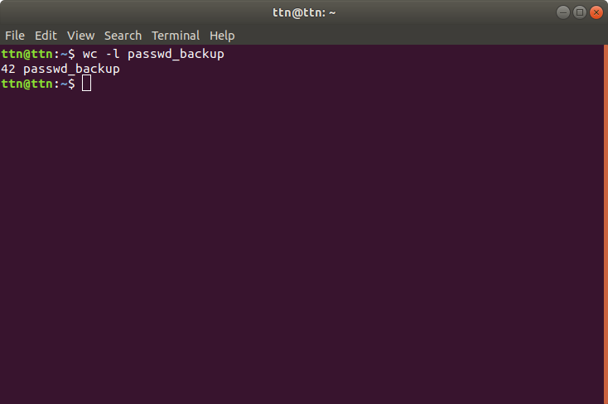

7)Get the first 5 lines of a file “password_backup” and Redirect the output of the above commands into file "output".

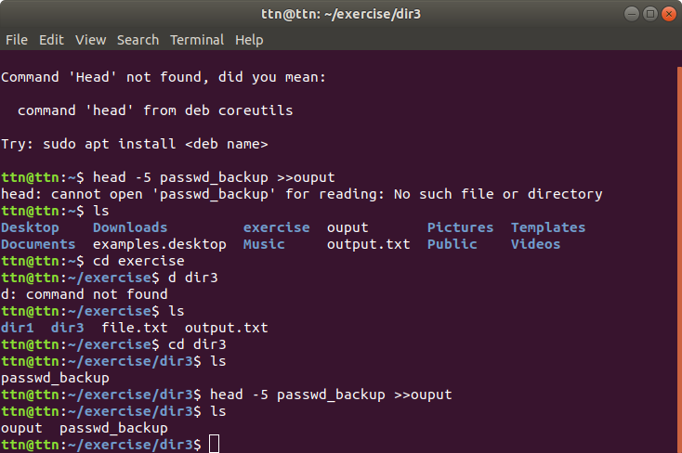

8)Create a "test" user,create its password and find out its uid and gid

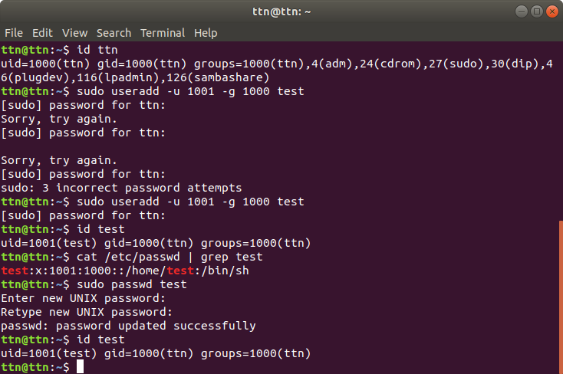

9)Change the timestamp of emptyFile1,emptyFile2 which are exist in dir2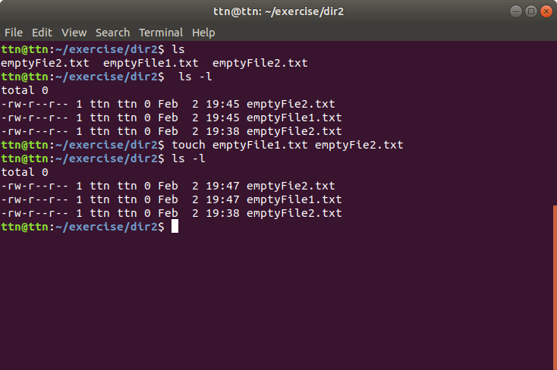

11)Create alias with your name so that it creates a file as "/tmp/aliastesting"

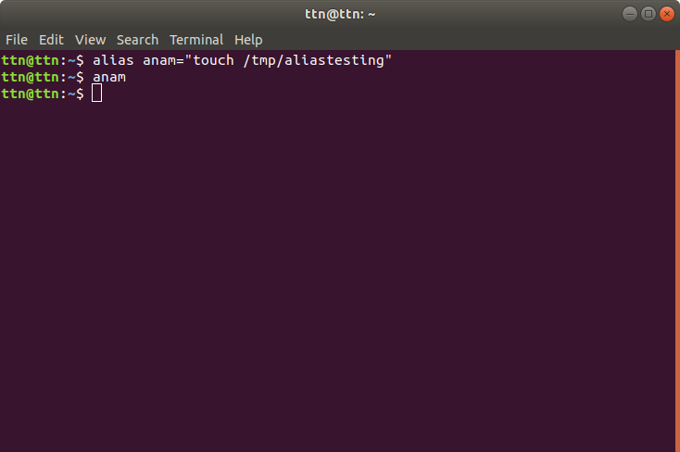

12)Edit ~/.bashrc file such that when you change to "test" user it should clear the screen and print "Welcome"

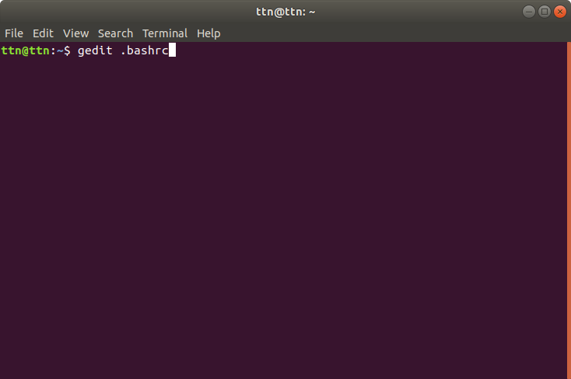

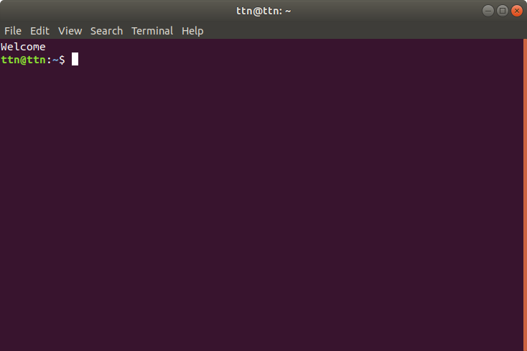

13)Install “zip” package.

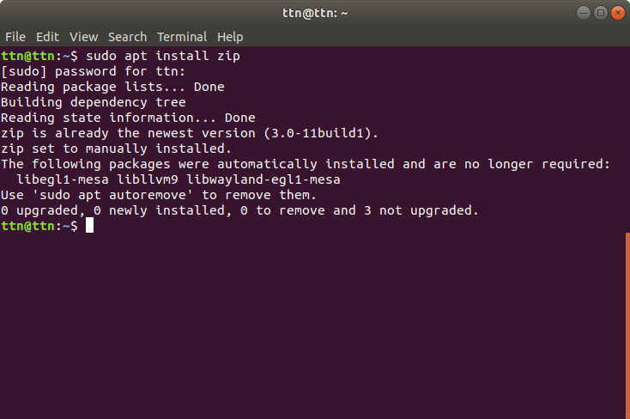

14)Compress "output" and "password_backup" files into a tar ball. List the files present inside the tar created.

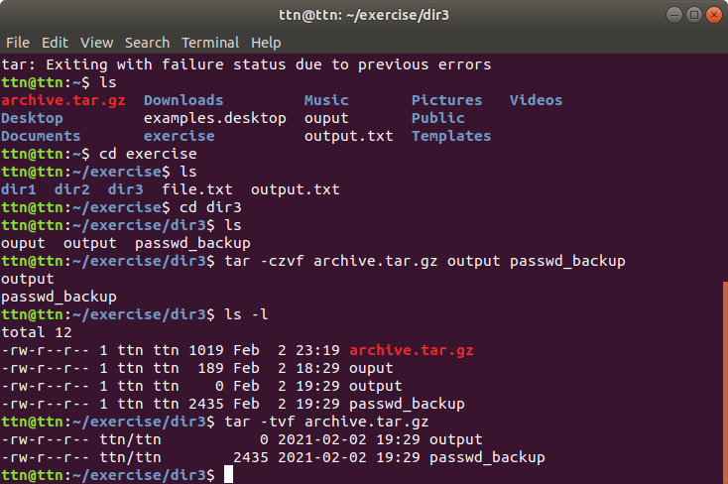

17)Download any image from web and move to desktop

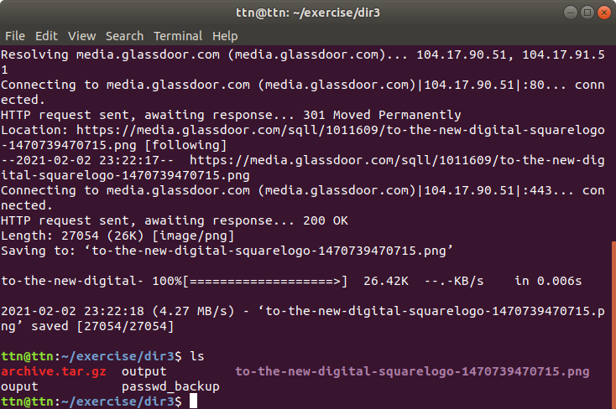

18) How to get help of commands usages.

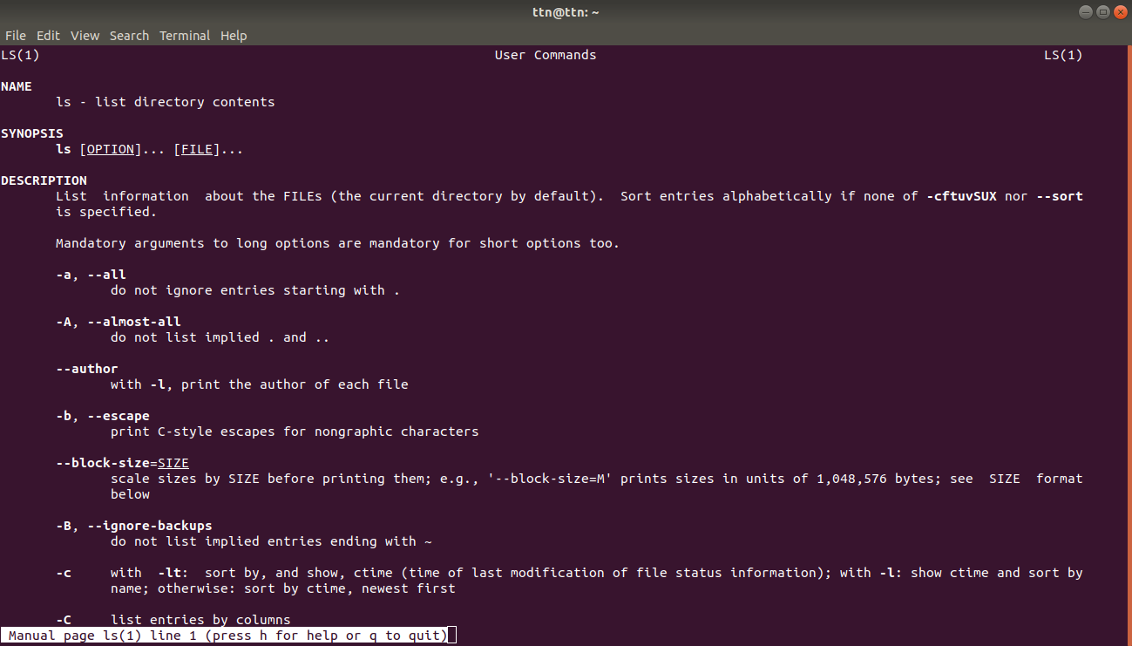

19)Create a symlink of /etc/services into /tmp/ports-info

